5/28/2019

Scott Fiene

Performance Wellness Database

This Page Unintentionally Left Blank

Contents

Section 1 – Requirements 2

Business Description 2

Business Problems 2

Business Requirements 2

Section 2 – Data Model 5

Conceptual Data Model 5

Entity Descriptions 5

Logical Design 7

Section 3 – Physical Database 7

SQL Code for Table Creation in SQL Server 2017 8

SQL Code to Load Tables with Data in SQL Server 2017 10

Section 4 – Database Queries 11

Complex SQL Queries 14

Section 5 – Data Warehouse Design 18

# Section 1 – Requirements

## Business Description

I will be modeling this project database from a company I work for called Performance Wellness (PW). PW north and PW south are chiropractic business that serves the north and south sides of Indianapolis, IN, respectively. There are also 5 other offices in Indiana in Evansville, Castleton, Fort Wayne, Merrillville, and Elkhart. While the offices are separate, PWN is the main office and where the whole business is managed out of. The services that are provided include, but not limited to:

* Chiropractic adjustments
* Electrical muscle stimulation
* Heat and cold therapy
* Massage
* Mechanical traction
* Dry hydrotherapy
* Therapeutic exercise

Priority Pain Solutions is another part of our company, but still separate. It is run by a sports medicine MD and patients are referred to it only through the chiropractors in the above-mentioned offices.

I think that it would be beneficial if all the offices could be connected to a database and then virtually connected to each other. This would be beneficial for several reasons, but the main reason would be for patient adherence, billing and scheduling across all the offices. There are many aspects that can go into this DW, but only the patient system will be the focus

## Business Problems

* All offices are separate from each other so there is no way for the owner to find out how each of the offices are doing. I would imagine that there is a way to see P & L statements and year-to-date financial information, but I do not know how. Implementation of a DW would make it so all the information can be queried into one easy to see dashboard in one place for all the offices
* PPS is part of the therapy to help reduce pain but being that it is run by an MD it has a separate system still. Incorporating this will result in one click scheduling for the prescribing doctor
* The availability of the WIFI and VPN provided by our current provider is subpar, and is subject to frequent outages so a DW would be beneficial for the patient information backup
* The system currently in use is slow and difficult to navigate because of the amount of services that they offer. We only use 2-3 of the services. Having a DB and DW we could deploy app specific to our company without any extra costs to an outside provider.

## Business Requirements

#### Operational System

1. The system will require that all office systems are identical
2. The system needs to require all patients to fill out new patient information and consent forms
3. The systems must require all the pertinent information to be entered before saving and continuing the new patient process
4. The system must require a first name, last name, and time to check the patient in for treatment and allow patients to select their optional therapies
5. The system will require patients to come in at their scheduled time or require them to reschedule for another time
6. The system will have operational hours to reflect those of the business and will not let patients check in any sooner or later than those hours
7. The system needs to allow people to check in via some form of identification device – id scanner, thumbprint scanner, signature pad, pin pad, etc.
8. The system needs to require the therapeutic exercises and chiropractic adjustment for each patient
9. The system needs to optionally allow patients to select what therapies they want to receive that visit on top of the required two
10. The system needs to provide customer with an external portal to access outside of the office for scheduling and bill view
11. The system needs to provide an information knowledge base for patients to learn more information

#### Data Warehouse

For the patient information DW the only required necessity would be to store all patient’s information from all offices. This is required for analysis purposes so that we can determine financial information like P&L statement and projections, and provide a place for exploratory data analysis to find improvements or other information that may be useful to the company

#### Technical Requirements

* SQL Server 2017
* Visio 365
* Visual Studio 2017

#### Data Requirements

* Each patient must have a Patient ID
* The Patient ID is required to be 5 numbers in length. Must be in numbers
* Each new patient will receive a new ID regardless if they are a previous patient or not
* Each patient file will have a treatment plan associated with it
* Each patient file must have the following information:
  + Personal
    - Address
      * City
      * State
      * Zip
      * Street name
      * Street number
    - Name
      * First
      * Middle
      * Last
    - Contact info
      * Phone number
      * Email
    - Copy of State ID
  + Treatment Plan
    - Schedule
      * Month
      * Day
      * Year
      * Time of day
      * Day of week
    - Attending Chiropractor
    - Required therapies
      * Therapeutic Exercise
      * Adjustment
    - Optional therapies
      * Dry Hydrotherapy
      * Electrical stimulation
      * Massage
      * Mechanical traction
    - ICD-10 Codes
* Each patient file must be kept minimum of 7 years per HIPAA and in case a file goes into deposition with the courts
* Each patients schedule must contain month, day, year, time of day and days of week being prescribed
* Treatment plan ICD-10 Codes to be able to prescribe the therapies
* Each patient file must have a copy of a state issued ID

#### Data Warehouse

* Each day’s metrics (how many patients, the patients ID, what therapies, etc.) will be stored at atomic granularity in a daily transaction fact table
* Each week’s metrics will be store in a weekly fact table
* Each month’s metrics will be stored in a monthly fact table
* The PatientID will be linked to the PatientDim and the TreatmentDim
* The PatientDIM will contain all the personal information about each patient including but not limited to name, address, and contact information
* The TreatmentDim will contain all the information about each patient’s treatment plan and will include but no limited to ICD-10 billing codes, attending chiropractor, and schedule
* All the financial metrics will include but is not limited to insurance payments, lawyer fees, and employee income.

#### Business Rules

* A patient can have 1 or more PatientID
* A PatientID can only have 1 PersonInfo
* PersonInfo can only have 1 ContactInfo
* PersonInfo can only have 1 name
* PersonInfo can have 1 or more addresses
* A PatientID can have 1 or more TreatmentPlan
* A TreatmentPlan must have 1 chiropractor but may have multiple Chiropractors
* A TreatmentPlan must have 1 ReqTherapies
* A TreatmentPlan can only have 1 schedule
* A TreatmentPlan must have 1 or more ICD_10_Codes
* Address is a composite field made of Zip, State, StreetNumber, StreetName, City
* Name is a composite field made of FirstName, LastName, MiddleName
* Schedule is a composite field made of DayOfWeek, TimeOfDay, Year, Month, Day

# Section 2 – Data Model

## Conceptual Data Model

Page-1

### Entity Descriptions

There are 7 entities and 3 composite entities. The ICD_10_Codes and Chiropractor entity lead to other table that are beyond the scope if this project

* **PatientID** – This is the main component in patient scheduling. It links all the personal information and treatment plan to the other databases that are beyond the scope of this project
  + **PatientID** – 5-digit unique number
  + **PersonID** – consists of first 2 letters of patients first name, first 3 letters of patients last name, and their 5-digit PatientID (ex. Scfie12345)
  + **TreatmentID** – consists of first 2 letters of patients first name, first 3 letters of patients last name, and their 5-digit PatientID (ex. Scfie12345)
* **PersonInfo** – This entity contains all the personal information about the patient as well as the preferred contact methods and address
  + **PersonID**
  + **Name** – composite entity consisting of
    - FirstName
    - LastName
    - MiddleName
  + **Address** – composite entity consisting of
    - City
    - State
    - Zip
    - Street Name
    - Street Number
  + **ContactInfo** – The patients’ methods of contacts and the preferred method of contact
    - PhoneNumber
    - Email
    - Preference – preferred contact method
* **TreatmentPlan** – Contains the patients’ treatment plan information and schedule
  + **TreatmentID**
  + **ReqTherapies**
    - **TreatmentID**
    - Adjustment – chiropractic adjustment
    - TE – therapeutic exercise
    - MechTrac – mechanical traction
    - ElecStim – electrical stimulation
    - Massage
    - DryHydro – dry hydrotherapy
  + **Schedule** – When the patient is required to come in
    - **ScheduleID**
    - **Schedule**
      * Day
      * Month
      * Year
      * TimeOfDay
      * DayOfMonth
      * AmPm
* **Chiropractor** – contains information related to the attending chiropractor
  + **ChiroID**
  + FirstName
  + LastName
* **ICD_10_Codes** – required to provide treatment to the patient
  + **CodeID**
  + Code – ICD-10 medical codes that tell what we are billing for and what we can treat for

Logical DesignPage-1

# Section 3 – Physical Database

**Patient**

|  |  |  |
| --- | --- | --- |
| **PatientID** | **PersonID** | **TreatmentID** |

**PersonInfo**

|  |  |  |  |  |  |  |  |  |  |
| --- | --- | --- | --- | --- | --- | --- | --- | --- | --- |
| **PersonID** | **ContactID** | StreetNumber | StreetName | City | State | Zip | FirstName | MiddleName | LastName |

**ContactInfo**

|  |  |  |  |
| --- | --- | --- | --- |
| **ContactID** | PhoneNumber | Email | Preference |

**TreatmentPlan**

|  |  |  |  |  |
| --- | --- | --- | --- | --- |
| **TreatmentID** | **ChiroID** | **CodeID** | **TherapyID** | **ScheduleID** |

**ICD_10_Codes**

|  |  |
| --- | --- |
| **CodeID** | ICD_10_Codes |

**Appointment**

|  |  |  |  |  |  |
| --- | --- | --- | --- | --- | --- |
| **ScheduleID** | DayOfWeek | TimeOfDay | Day | Month | Year |

*For the composite attribute Address, I had to break it apart when creating the table for normalization purposes

*Added an AmPm field to denote which appointments are morning or evening

**Chiropractor**

|  |  |  |
| --- | --- | --- |
| **ChiroID** | FirstName | LastName |

**ReqTherapies**

|  |  |  |  |  |  |  |
| --- | --- | --- | --- | --- | --- | --- |
| **TherapyID** | Adjustment | TE | MechTrac | ElecStim | Massage | DryHydro |

**\***Used a bit field type to denote either yes or no via 1 and 0

## SQL Code for Table Creation in SQL Server 2017

CREATE TABLE PatientFile

(

PatientID varchar(5) NOT NULL,

PersonID varchar(10) NOT NULL,

TreatmentID varchar(10) NOT NULL,

PRIMARY KEY (PatientID),

FOREIGN KEY (PersonID) REFERENCES PersonalInfo (PersonID),

FOREIGN KEY (TreatmentID) REFERENCES TreatmentPlan (TreatmentID)

);

CREATE TABLE PersonalInfo

(

PersonID varchar(10) NOT NULL,

ContactID varchar(5) NOT NULL,

FirstName varchar(25) NOT NULL,

LastName varchar(25) NOT NULL,

StreetNumber varchar(10) NOT NULL,

StreetName varchar(50) NOT NULL,

City varchar(25) NOT NULL,

State varchar(2) NOT NULL,

Zip varchar(5) NOT NULL,

PRIMARY KEY (PersonID),

FOREIGN KEY (ContactID) REFERENCES ContactInfo (ContactID)

);

CREATE TABLE ContactInfo

(

ContactID varchar(5) NOT NULL,

PhoneNumber varchar(12) NOT NULL,

Email varchar(50) NOT NULL,

Prefrence varchar(10) NOT NULL,

PRIMARY KEY (ContactID)

);

CREATE TABLE TreatmentPlan

(

TreatmentID varchar(10) NOT NULL,

ChiroID int NOT NULL,

CodeID varchar(8) NOT NULL,

TherapyID varchar(5) NOT NULL,

ScheduleID varchar(5) NOT NULL,

PRIMARY KEY (TreatmentID),

FOREIGN KEY (ChiroID) REFERENCES Chiropractor (ChiroID),

FOREIGN KEY (CodeID) REFERENCES ICD_10_Codes (CodeID),

FOREIGN KEY (TherapyID) REFERENCES ReqTherapies (TherapyID),

FOREIGN KEY (ScheduleID) REFERENCES Appointment (ScheduleID)

);

CREATE TABLE ICD_10_Codes

(

CodeID varchar(8) NOT NULL,

Code_Name varchar(30) NOT NULL

PRIMARY KEY (CodeID)

);

CREATE TABLE Appointment

(

ScheduleID varchar(5) NOT NULL,

TimeOfDay time NOT NULL,

AmPm char(2),

Day varchar(3) NOT NULL,

DayOfMonth int NOT NULL,

Month varchar(15) NOT NULL,

Year int NOT NULL,

PRIMARY KEY (ScheduleID)

);

CREATE TABLE Chiropractor

(

ChiroID int IDENTITY(1,1) NOT NULL PRIMARY KEY,

FirstName varchar(25) NOT NULL,

LastName varchar(25) NOT NULL

);

CREATE TABLE ReqTherapies

(

TherapyID varchar(5) NOT NULL PRIMARY KEY,

MechTrac bit,

Adjustment bit NOT NULL,

TE bit NOT NULL,

DryHydro bit,

Massage bit,

ElecStim bit

);

GO

## SQL Code to Load Tables with Data in SQL Server 2017

INSERT INTO PatientFile VALUES ('00001', 'jodoe00001', 'jodoe00001');

INSERT INTO PatientFile VALUES ('00002', 'jadoe00002', 'jadoe00002');

INSERT INTO PatientFile VALUES ('00003', 'mamil00003', 'mamil00003');

INSERT INTO PatientFile VALUES ('00004', 'bishe00004', 'bishe00004');

INSERT INTO PatientFile VALUES ('00005', 'momil00005', 'momil00005');

INSERT INTO PatientFile VALUES ('00006', 'scfie00006', 'scfie00006');

INSERT INTO PersonalInfo VALUES ('jodoe00001', '00001', 'John', 'Doe', '111', 'Maple Ave', 'Indianapolis', 'IN', '46260');

INSERT INTO PersonalInfo VALUES ('jadoe00002', '00002', 'Jane', 'Doe', '456', 'Wall Way', 'Indianapolis', 'IN', '46260');

INSERT INTO PersonalInfo VALUES ('mamil00003', '00003', 'Mary', 'Miller', '14556', 'Appleton Court', 'Indianapolis', 'IN', '46260');

INSERT INTO PersonalInfo VALUES ('bishe00004', '00004', 'Bill', 'Sheppard', '739', 'Delta Street', 'Indianapolis', 'IN', '46256');

INSERT INTO PersonalInfo VALUES ('momil00005', '00005', 'Monique', 'Miles', '300', 'South Way', 'Indianapolis', 'IN', '46231');

INSERT INTO PersonalInfo VALUES ('scfie00006', '00006', 'Scott', 'Fier', '7', 'Hullabaloo Court', 'Carmel', 'IN', '46033');

INSERT INTO ContactInfo VALUES ('00001', '317-677-0789', 'jrdoe@hotmail.com', 'Phone');

INSERT INTO ContactInfo VALUES ('00002', '317-709-1313', 'jane_d14@google.com', 'Phone');

INSERT INTO ContactInfo VALUES ('00003', '317-553-3535', 'miller_time@google.com', 'Email');

INSERT INTO ContactInfo VALUES ('00004', '812-688-5643', 'williamshep@yahoo.com', 'Phone');

INSERT INTO ContactInfo VALUES ('00005', '756-131-4456', 'mon4miles@google.com', 'Email');

INSERT INTO ContactInfo VALUES ('00006', '317-551-9812', 'fierfier@outlook.com', 'Phone');

INSERT INTO TreatmentPlan VALUES('jodoe00001', '1', 'S13.4XXA', '00001', '00001');

INSERT INTO TreatmentPlan VALUES('jadoe00002', '1', 'S23.3XXA', '00002', '00002');

INSERT INTO TreatmentPlan VALUES('mamil00003', '1', 'S33.5XXA', '00003', '00003');

INSERT INTO TreatmentPlan VALUES('bishe00004', '1', 'S29.012A', '00004', '00004');

INSERT INTO TreatmentPlan VALUES('momil00005', '2', 'S13.4XXA', '00005', '00005');

INSERT INTO TreatmentPlan VALUES('scfie00006', '2', 'S39.012A', '00006', '00006');

INSERT INTO ICD_10_Codes VALUES('S13.4XXA', 'Sprain Cervical Spine');

INSERT INTO ICD_10_Codes VALUES('S16.1XXA', 'Strain Neck Muscle');

INSERT INTO ICD_10_Codes VALUES('S23.3XXA', 'Sprain Thoracic Spine');

INSERT INTO ICD_10_Codes VALUES('S29.012A', 'Strain Thoracic Muscle');

INSERT INTO ICD_10_Codes VALUES('S33.5XXA', 'Sprain Lumbar Spine');

INSERT INTO ICD_10_Codes VALUES('S39.012A', 'Strain Lumbar Muscle');

INSERT INTO Appointment VALUES('00001', '9:15', 'AM', 'Mon', '1', 'May', '2018');

INSERT INTO Appointment VALUES('00002', '2:00', 'PM', 'Mon', '1', 'May', '2018');

INSERT INTO Appointment VALUES('00003', '5:00', 'PM', 'Mon', '1', 'May', '2018');

INSERT INTO Appointment VALUES('00004', '10:00', 'AM', 'Tue', '2', 'May', '2018');

INSERT INTO Appointment VALUES('00005', '11:00', 'AM', 'Tue', '2', 'May', '2018');

INSERT INTO Appointment VALUES('00006', '3:45', 'PM', 'Tue', '2', 'May', '2018');

INSERT INTO Chiropractor VALUES('Branden', 'Coleman');

INSERT INTO Chiropractor VALUES('Jacob', 'Roberts');

INSERT INTO Chiropractor VALUES('Bryan', 'Walters');

INSERT INTO ReqTherapies VALUES('00001', '0', '1', '1', '1', '0', '1')

INSERT INTO ReqTherapies VALUES('00002', '1', '1', '1', '0', '1', '1')

INSERT INTO ReqTherapies VALUES('00003', '1', '1', '1', '1', '0', '1')

INSERT INTO ReqTherapies VALUES('00004', '1', '1', '1', '0', '1', '1')

INSERT INTO ReqTherapies VALUES('00005', '1', '1', '1', '0', '0', '0')

INSERT INTO ReqTherapies VALUES('00006', '0', '1', '1', '0', '0', '0')

# Section 4 – Database Queries

Query #1 – person id associated with name

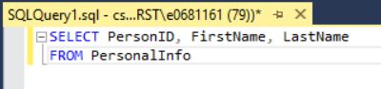

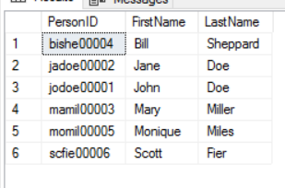

Query #2 – pt who has address as 46260

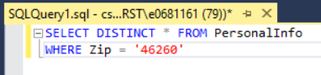

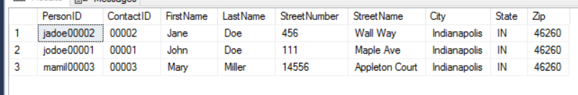

Query #3 – first name and contact id

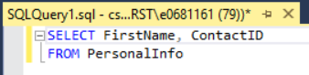

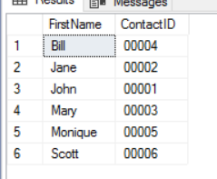

Query #4 – How many patients Dr. Coleman has vs. how many Dr. Roberts has

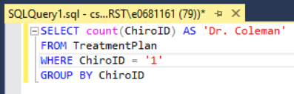

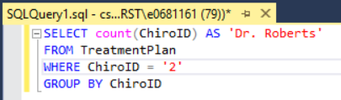

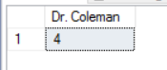

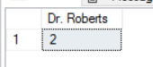

Query #5 – appointments between 9am and 12pm

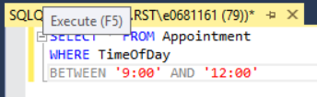

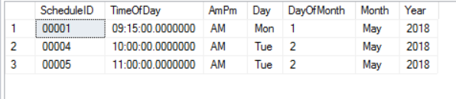

## Complex SQL Queries

Query #1

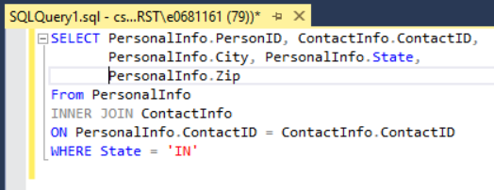

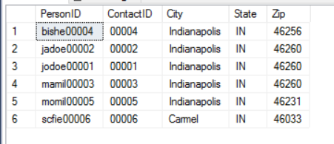

Query #2 – To find out what patient is scheduled to which doctor on which day

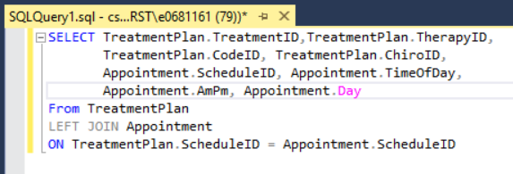

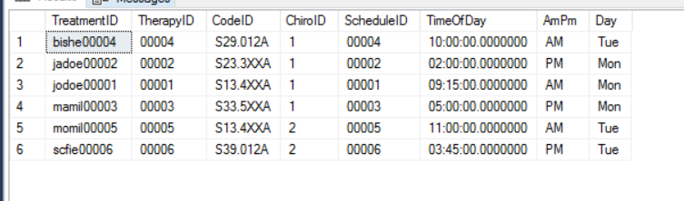

Query #3 – Which Chiropractor is associated with which patient

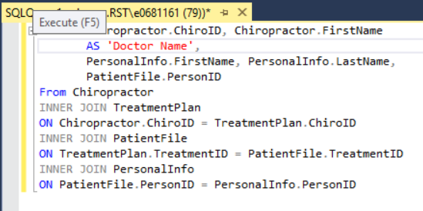

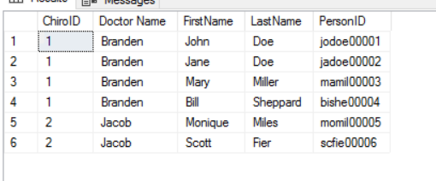

Query #4 – Complete customer personal information

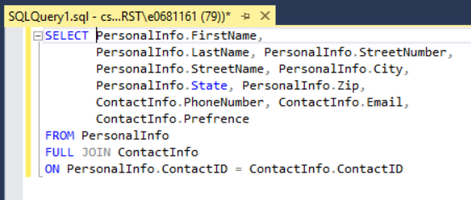

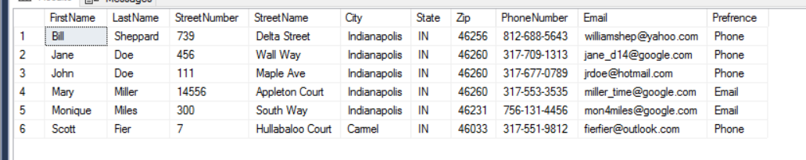

Query #5 – Codes, doctor, and therapies for each patient

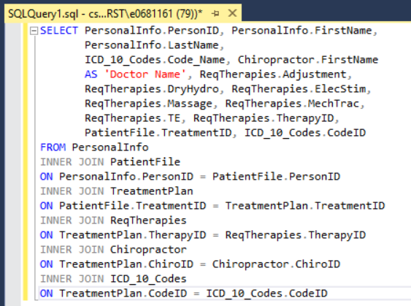

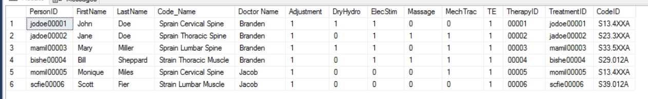

# Section 5 – Data Warehouse Design

A data warehouse for PW would be very useful to the business owner and decision makers. It would allow queries of all financial information needed. It would also be beneficial for finding which patients have not been coming in regularly.

The design while able to be done by a team of professionals is beyond my skill level. It would be a massive undertaking required more databases be created such as billing, patient check-ins, lawyer, information, insurance information.

When I first decided on what I wanted to do I thought it would be way less intricate to put together. I had to reduced the amount of information I put into the database by more than half.

#### Data Mart

A couple data marts would be beneficial. One data mart would be for key financials, and another data mart would hold all the patient information. Financials could be broken down into 2 separate marts billing and income